GeekGang

A place to meet with Tech Savvy Society­­

- Website on which we can know about technical, Non-technical and cultural meet-ups, Seminars, workshop, get together.

Three DataTable:

1. User
2. Meetup
3. Management

- There are three major Domain class

* User :
  + **UserID**
  + FirstName
  + LastName
  + Email
  + Password
* Management
  + **ID**
  + MeetID
  + UserID
  + Status
* Meetup
  + **MeetID**
  + UserID
  + Title
  + DateTime
  + Location
  + Time
  + Tag
  + AttendeesCapacity
  + NoOfAttendees
  + Detail

GeekGang

Host

Meet

Attend

Meet

Description (Body)

Subject

Email

Follow Us:

1. Facebook
2. Instagram
3. Twitter
4. Medium

* Help
* About Us
* Topics
* Contact Us
* Terms

**Host Meet**

Date

Time

Meetup7

Date

Time

Meetup6

Date

Time

Meetup5

Date

Time

Meetup3

Date

Time

Meetup2

Date

Time

Meetup8

Date

Time

Meetup4

Date

Time

Meetup1

All Meets >

Find Your Next Meet

***Let’s***

***Meet***

***Geek***

And I’m in mood for (Tag)

In (Location)

I want to go out (Date)

Go

(**Feature1**)

Login

Signup

**“Attend Meet” Page:**

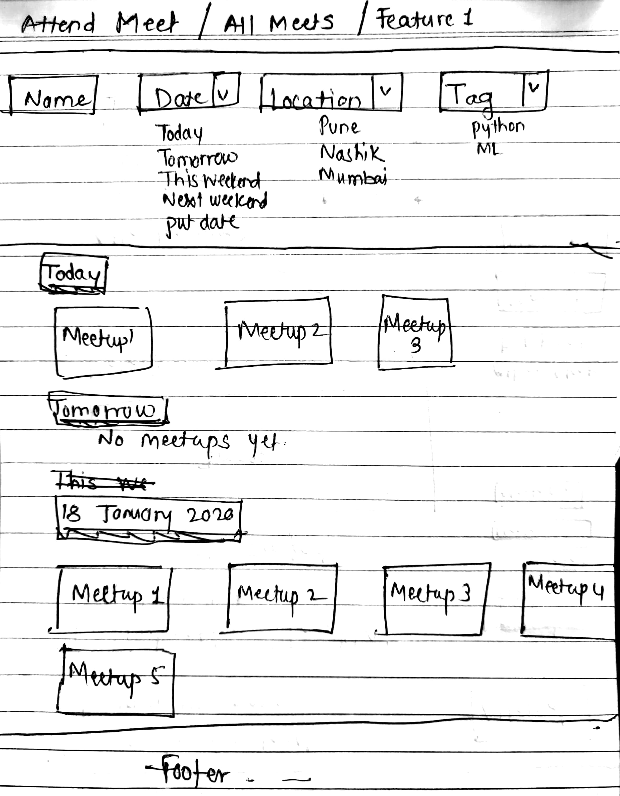

**“Main Meetup” Information Page:**

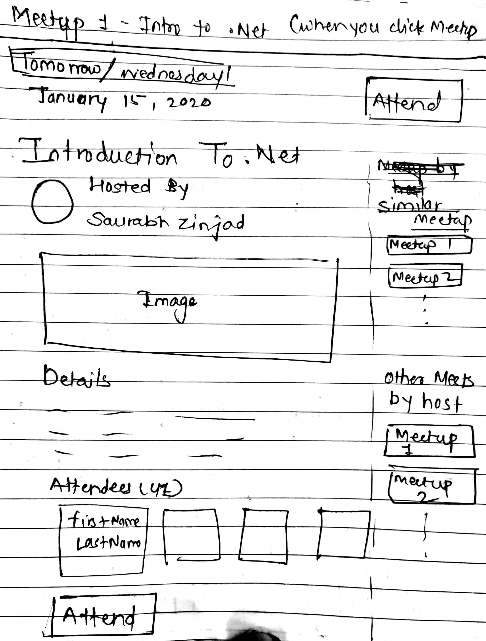

**“Host Meet” Page:**

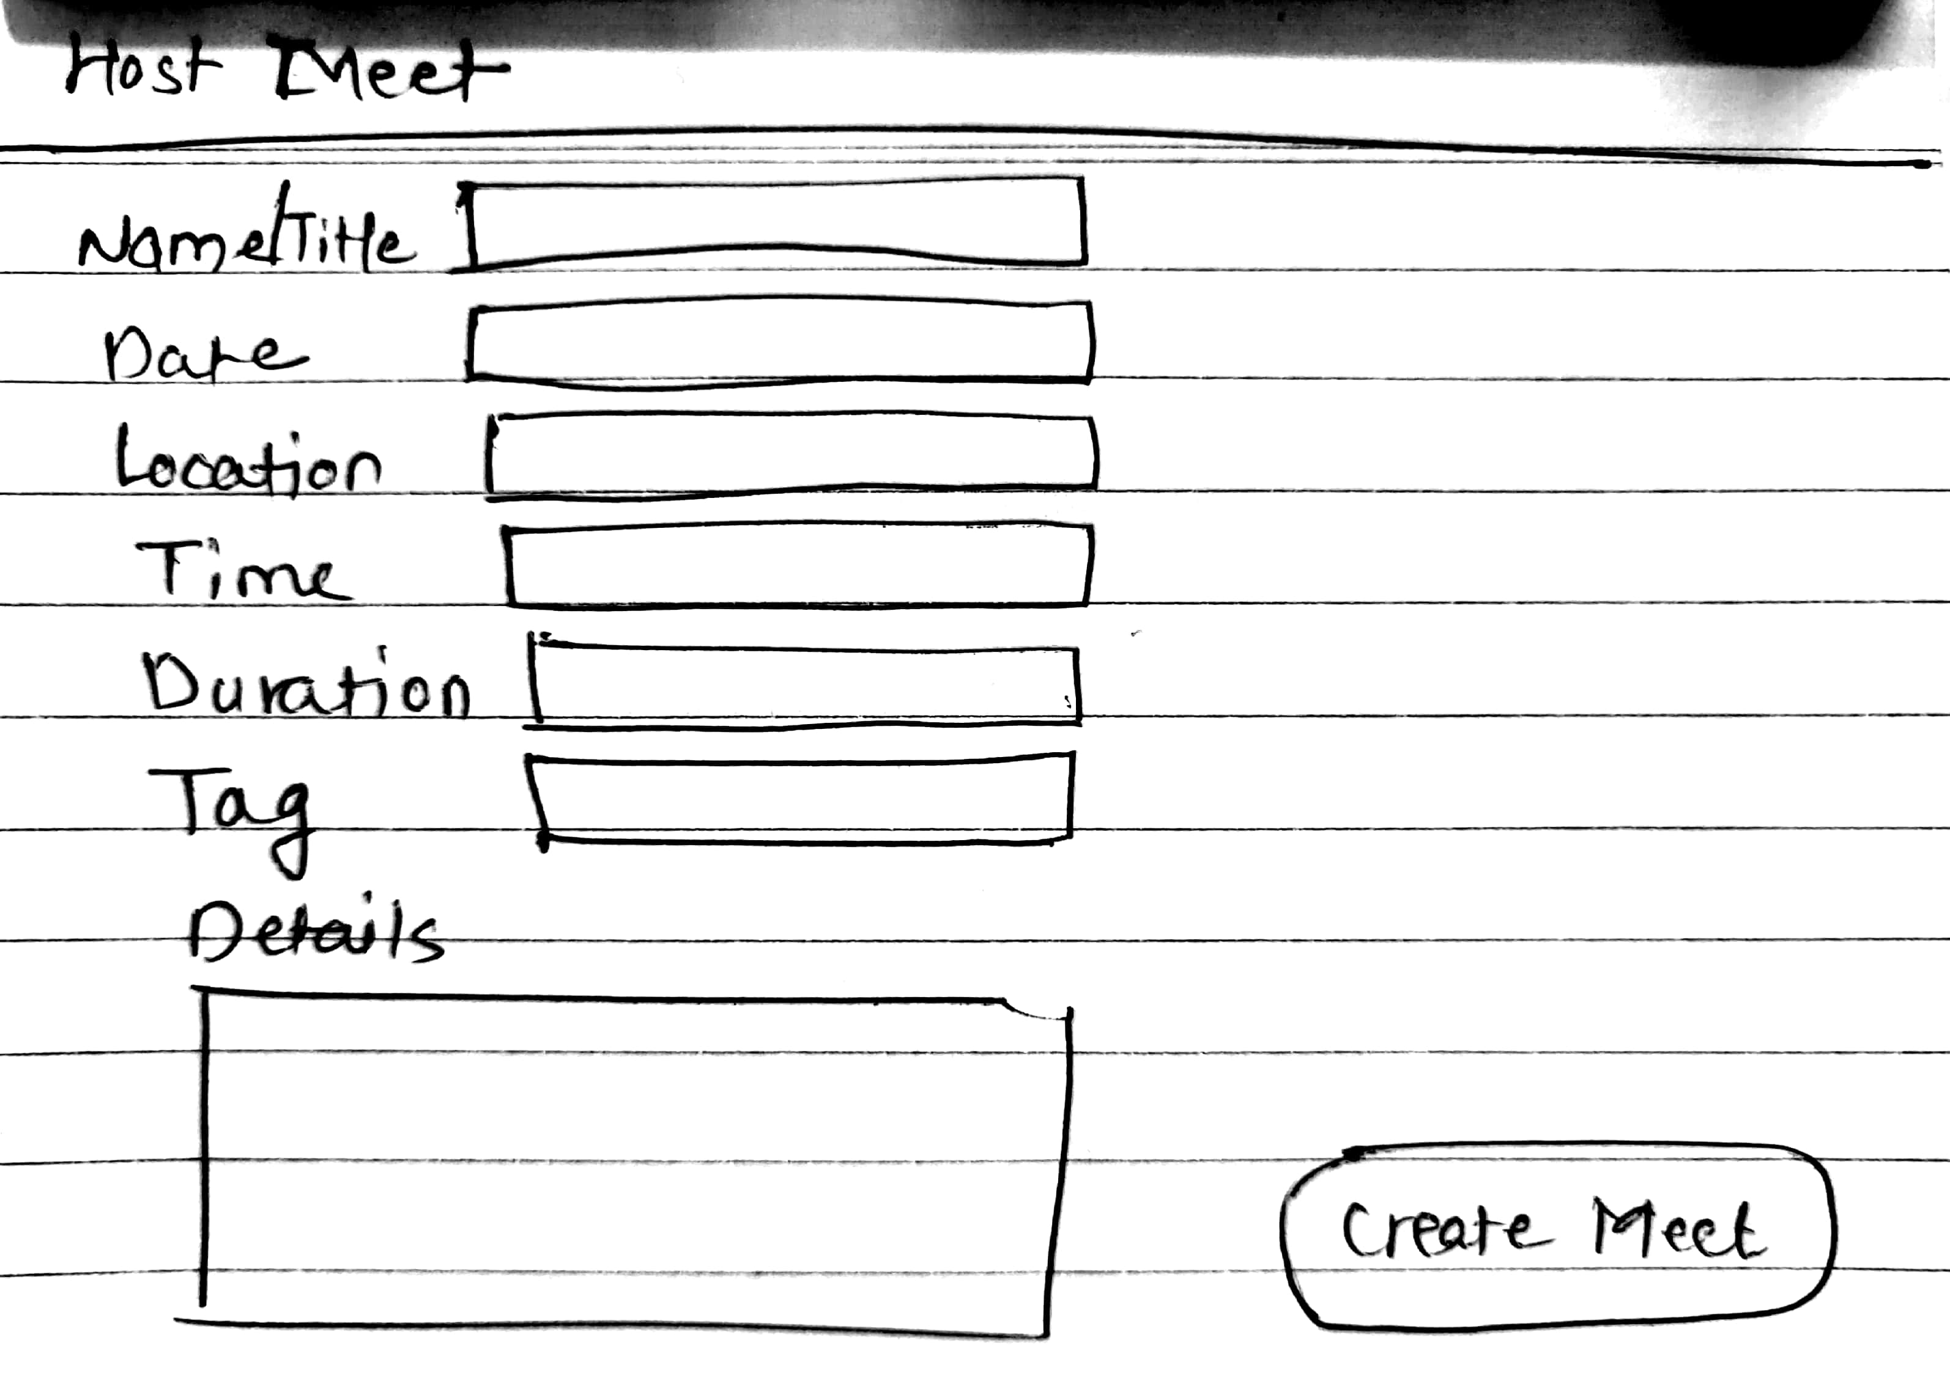

**“Login: Page: “Sign Up” Page:**

